**Warehouse Management System**

**Introduction to Programming**

**CMPT 120L 114**

**Team ABC**



Marist College

School of Computer Science and Mathematics

Submitted To:

Dr. Reza Sadeghi

Fall 2022

Intro to programming_Project Progress Report_Phase #1_Team ABC

**Project Progress Report #2 of Warehouse Management System**

**Table of Contents**

Project Object/Description……………………………………………………………..………….4

GitHub Repository Address………………………………………………………………….……6

Graphical User Experience Design………………………………………………………………..7

Graphical User Interface Design…………………………………………………………………..9

Login Page………………………………………………………………………………...9

Admin Main Menu……………………………………………………………….………..9

Admin Products Page……………………………………………………………………10

Admin User Window…………………………………………………………………….10

User Main Menu…………………………………………………………………………11

User Product Window……………………………………………………………………11

**Table of Figures**

Figure 1 …………………………………………………………………………………………7

Figure 2 …………………………………………………………………………………………9

Figure 3 …………………………………………………………………………………………9

Figure 4 ………………………………………………………………………………………...10

Figure 5 ………………………………………………………………………………………...10

Figure 6 …………………………………………………………………………………………11

Figure 7 ……………………………………………………………………….…………………11

**Project Description: Warehouse Management System**

**Summary**: The warehouse management system (WMS) provides an organized way of storing different products and elements in a warehouse. You can consider a library as a warehouse, which maintains books’ details and user libraries. A general WMS stores details of name and identification number of products, their store time, the required storage condition, price, weight, height, etc. following this, this system allows guest users to search for different content and request to borrow/buy them. Your WMS will store the data of different user types in distinct SQL tables. This system should at least support the following items:

1. Admin user is capable of:
   1. Having admin user and password for log in (a string of at least 8 characters)
   2. Changing the admin user and admin password
   3. Adding a guest user to WMS by creating a new username and password. a guest user is not able to define or remove other users.
   4. Removing users from WMS by removing their username, password, and corresponding recorded data.
   5. Adding an item to the warehouse with varied details, such as:
      1. Type: food, books, cars, etc.
      2. Stored time in the warehouse
      3. Pick out time from the warehouse
      4. ID: each item in your library should have a unique identification number with a specific format
      5. Name
      6. Provider/creator’s name
      7. Quantities: the number of available items. For instance, item x with a quantity of 2 is a sign of 2 available x items in your warehouse.
      8. Place: where the item is stored
      9. Price
   6. Deleting an item from the warehouse
   7. Editing an item in the warehouse
   8. Viewing the list of borrowing requests
   9. Accepting or rejecting a borrowing request
2. Each user should be able to:
   1. Search through WMS based on all items’ details, such as id, name, and producer.
   2. Save a list of favorite items 7
   3. Request to borrow/buy some items for a specific time. For example, borrowing an item for 3 weeks.
   4. View the history of borrowed items
3. WMS should be a user-friendly software, such that:
   1. It shows a welcome page
   2. It provides a menu of all functions to the user on all pages
   3. It illustrates the reports in a tabular form. For instance, it displays a well-organized list of the requested items.
   4. WMS should provide an exit function and thank the user for using this software.
   5. It shows a warning if:
      1. The admin user tries to add a new item to the library with an existing ID.
      2. If a guest user tries to borrow more than 3 items.
      3. A user search request returns null items.
4. WMS should protect the user information, such that
   1. Optional: WMS passwords and the recorded information should be ciphered. In the simplest case, you can use the caesar cipher methodology. The easiest way to understand the caesar cipher is to think of cycling the position of the letters. In a caesar cipher with a shift of 3, a becomes d, b becomes e, c becomes f, etc. When reaching the end of the alphabet it cycles around, so x becomes a, y becomes b, and z becomes c.

**GitHub Repository Address**

<https://github.com/Shannonmaier/-CMPT-120L-112_Warehouse-Management-System_Team-ABC->

**Graphical User Experience Design**

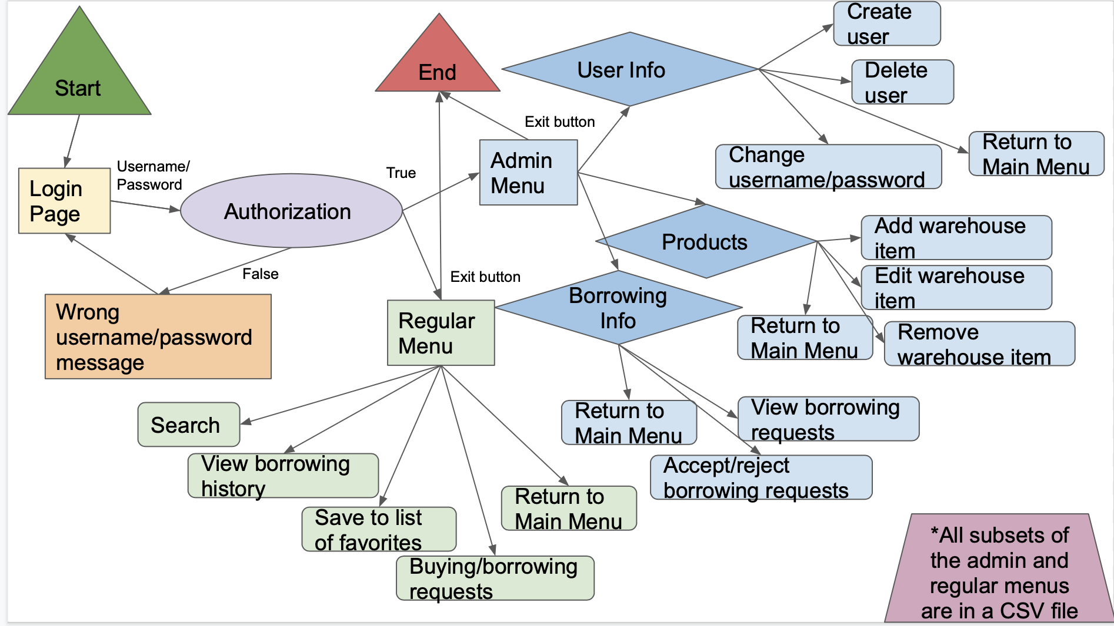

*Figure 1 - Warehouse Management Systems Flowchart*

**Description:**

**Login Page:**

Username and Password into two separate text boxes

Outputs:

* If the person enters a valid username and password, and it is the admin version, he or she will be granted access to the Admin Main Menu.
* If the user enters a valid username and password for a user, not the admin, he or she will be granted access to the User Main Menu
* If the user enters an invalid username or password, he or she will see a warning message

Admin Main Menu:

* This menu shows the user 5 Button options:
  + View products and product actions
    - If the person chooses this, more product options are shown
  + View Users and User Actions
    - More user options are shown in this page
  + View Borrow Requests
  + Change Admin User and Password
  + Exit

Admin Products and Actions Page:

* SHows product list
* Buttons to:
  + Add Product: adds a product to list
  + Remove Product: removes selected product from list
  + Edit Product: edits the product info
  + Search for Product
  + Go Back to Menu: goes back to admin menu

Admin User Window

* This window allows the administrator to edit the other user info
* Can:
  + Add a user
  + Remove a user
  + Go back to menu

Regular Menu: User Main Menu

* Shows the User the options to:
  + View Products and product actions
  + View favorite list
  + View borrowed Items History

User Product Window:

* Shows product list
* Buttons to
  + Add to favorites list
  + Request to Borrow
  + Search Product Library
  + Return to Menu

**Graphical User Interface Design** 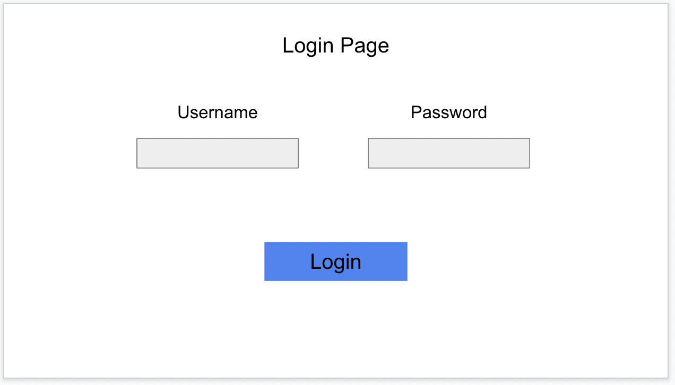

*Figure 2 -Login Page*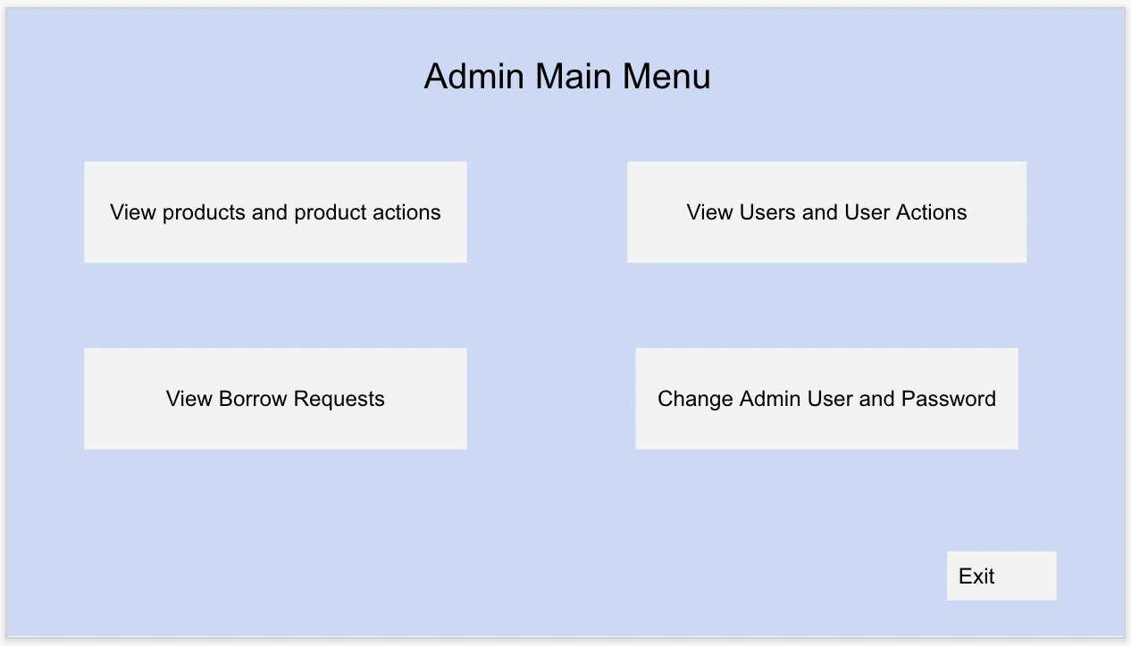

*Figure 3 - Admin Main Menu*

*Figure 4 - Admin Products and Actions Page*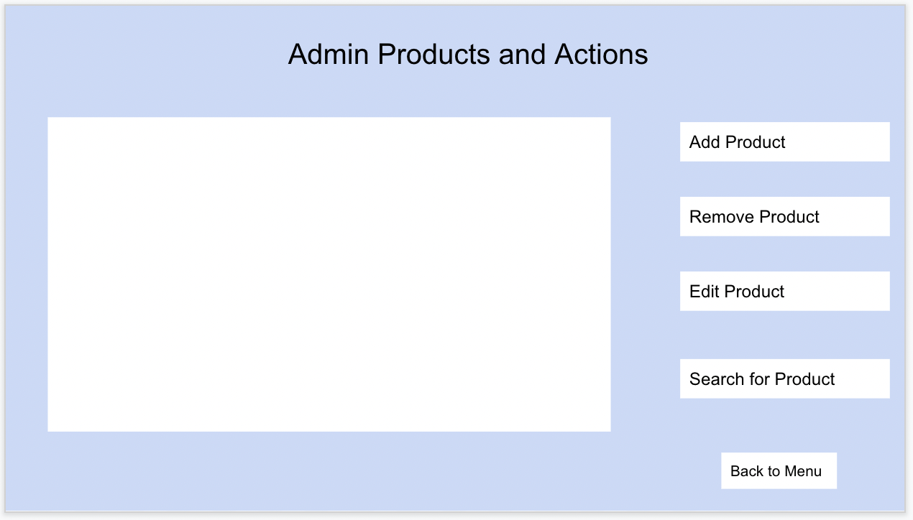

*Figure 5 - Admin User Editing Window*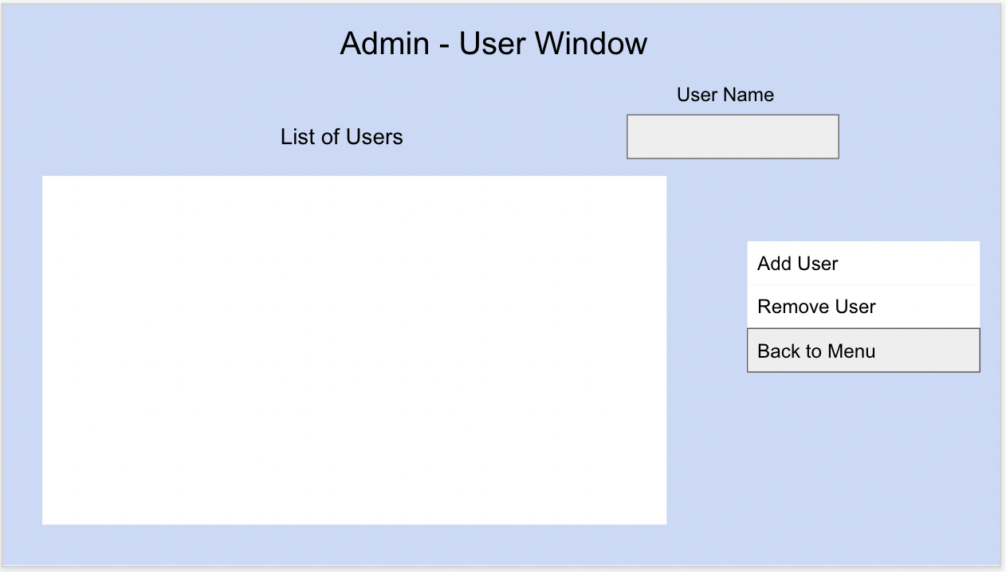

*Figure 6 - User Main Menu*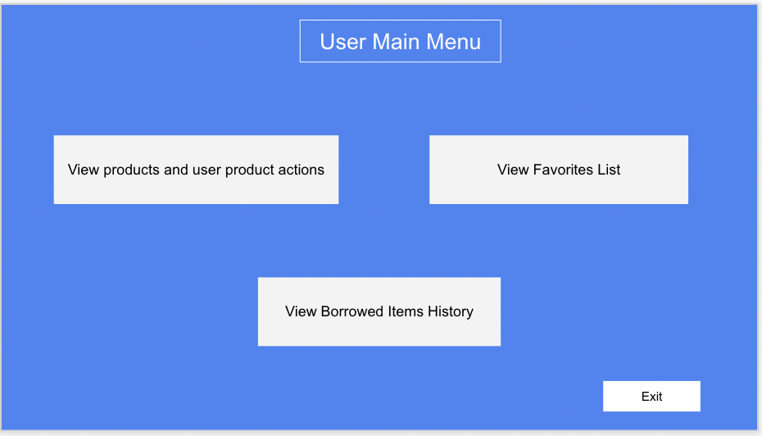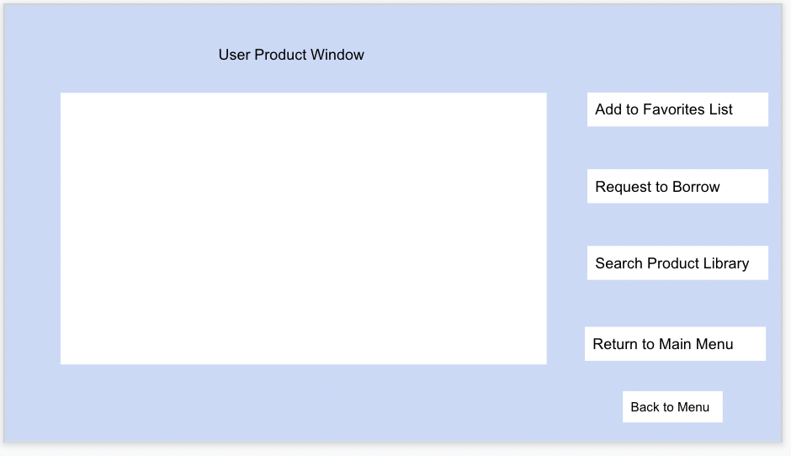

*Figure 7 - User Products and Actions Page*